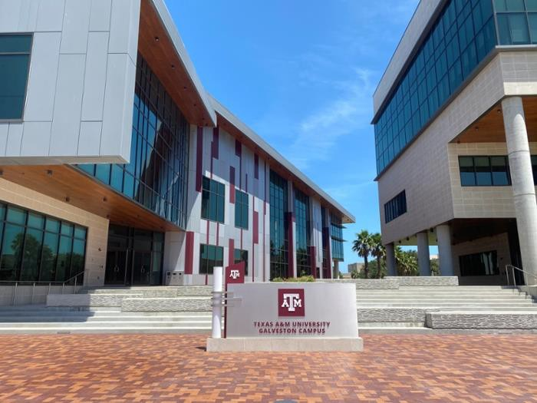

Department of Maritime Business Administration

**Graduate Student Handbook 2024-2025**

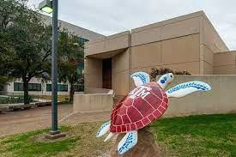

Summary of Contents

1. Introduction 3
2. Program Offerings 4

Master of Maritime Business Administration & Logistics 4

Graduate Certificate Maritime Business Administration 4

1. Program Organization 5
2. Admissions 6
   1. Application to the Master of Maritime Business Administration & Logistics 7
   2. Application to the Maritime Business Administration Certificate 7
   3. Additional Steps to Apply For License Option 8
   4. Additional Steps to Apply For the 3+2 Program 9
3. MARA Graduate Curriculum 9
4. Policies 11
5. About our Campus and Community 12

Appendix Howdy Portal and Division of Students’ Affairs 14

A little curiosity about our Building

*The Sea Turtle Statue installed at the Classroom Laboratory Building (CLB) Entrance was a donation by several Liberal Studies (LIST) Department Members in support of a local project in Galveston called “Turtles About Town”, a community art project created by Turtle Island Restoration Network and Clay Cup Studios. You can read more about this project at* [*https://www.visitgalveston.com/blog/turtles-about-town/*](https://www.visitgalveston.com/blog/turtles-about-town/)

# Introduction

We are excited you are exploring a career path full of promise, popularity, and to strive for your academic excellence here with us at the Department of Maritime Business Administration (MARA) of Texas A&M University at Galveston campus (TAMUG). Our programs offer a unique combination of business degree with a focus on the Maritime Transportation and Logistics. We offer a solid ***foundation in business*** courses and a diversity of ***maritime-specific*** elective courses. Furthermore, our faculty team is composed by world-

class researchers, professors and industry members actively collaborating and contributing

to research and workforce development in the maritime sector. Our faculty members are student-centric and work based on an open-door policy to advise and mentor you. We encourage you to take a detailed look at our faculty profile available at our home page (<https://www.tamug.edu/mara/faculty/index.html#Faculty>).

We also have a close relationship with the industry globally and locally within Houston- Galveston area. The MARA Department is an academic member of several industry organizations including AAPA (American Association of Port Authorities), IAPH (International Association of Ports and Harbors), and the GHPB (Great Houston Port Bureau), which assists us in helping our students to advance in their career path in this vibrant industry, which is the Maritime Business.

Striving for academic excellence and industry engagement, the MARA department conducts regular meetings with their Business Advisory Group, a committee composed of maritime industry leaders and TAMU alumni take give regular input and insights on curriculum and extra curriculum activities keeping our program up-to-date and relevant to the industry. Furthermore, MARA is also an active member of the IAMU (International Association of Maritime Universities) which provides additional insights into Maritime Training and Education and supports applied research in the maritime business field.

Texas A&M University at Galveston is one of the first designated Centers of Excellence (CoE) for Maritime Education and Training by U.S. Department of Transportation/MARAD and the only one that is integrated with a Tier 1 University (TAMU). Recently, the MARA Master program was also ranked by EDUniversal the #1 in the country and #8 globally for its

excellent achievements. (see more at [https://www.best-masters.com/ranking-master-maritime-](https://www.best-masters.com/ranking-master-maritime-management.html) [management.html)](https://www.best-masters.com/ranking-master-maritime-management.html)

This handbook was developed for future and current master’s and certificate students, and it contains a brief description of the graduate program procedures including admissions, program deadlines, advisory committee and degree plans, and common course offerings. The handbook is a supplementary document aimed at providing specific and useful program-related content. Additional policies and procedures for all Texas A&M University

Graduate and Professional School can be found on their home page

(<https://grad.tamu.edu/>) and additional Galveston Campus resources can be found at the

Research & Graduate Studies Office (RGSO) page <https://www.tamug.edu/rgso/>

# Program Offerings

Master of Maritime Business Administration & Logistics

The Master in Maritime Business Administration & Logistics is a highly competitive program that gives students the opportunity to elevate their learning and better prepare them for the mantle of leadership within a steadily growing industry. The coursework is a culmination of experienced experts sharing the latest advances within the industry, with which our program is heavily connected. This is 36-credit hours, divided into 21-credit hour of required courses and 15-credit hour of elective classes, excluding possible prerequisites that depends on each candidate's background (a complete list of courses and prerequisites can be found under item #5 of this handbook). The program

offers several routes to completion, including in person, fully online, or hybrid.

The program is also offered as an on- campus track that offers a License Option (LO) delivered in combination with the Texas A&M Maritime Academy (TAMMA) and the Department of Maritime Transportation (MART). Finally, the program can also be taken as a five-year combined undergraduate-graduate program, offering a faster track, also known as 3+2 program. Degree candidates that have an interest in developing their research and additional academic skills may also consider taking the Thesis Option offer. For additional details on each of those tracks, please refer to our home [page at](page%20at) <https://tamug.edu/mara/degrees/MMAL-Maritime->Administration- Logistics.html

Graduate Certificate Maritime Business Administration

The purpose of this 12-hour certificate is to educate and inform working professionals in a variety of fields (i.e., hospitals, ports, oil companies, etc.) of fundamental business processes to assist in their organizations for both profit and not-for-profit companies. The selection of courses reflects the most basic business processes, such as marketing, strategy, finance, and service operations management.

The Maritime Business Administration certificate includes 4 courses of 3-credit hours each as follows: MARA 612 Strategic Human Resource Management; MARA 627 Marketing of Maritime Services; MARA 616 Port, Terminal and Harbor Management; and MARA 650 Supply Chain Management. This certificate can be stand-alone or transferred into the Master of Maritime Business Administration & Logistics degree.

# Program Organization

The Master of Maritime Business Administration & Logistics and Maritime Business Administration Certificate programs are located within the Maritime Business Administration Department. The MARA Department Head and the MARA Graduate Program Chair oversee the management of the graduate degrees and certificate program, including curriculum, admissions, advising and other related policies and procedural decisions. The programs also count on the support of the staff members at Research and Graduate Studies Office (RGSO) and CALS (Center for Academic Learning Support) for additional assistance with advising, record-keeping and registration.

|  |  |  |
| --- | --- | --- |
| A person in a suit and tie  Description automatically generated  Amulya Gurtu  MARA Department Head, & Professor  E-mail:  [amulya.gurtu@tamu.edu](mailto:amulya.gurtu@tamu.edu)  Ph: +1 (409) 740.4441  Office: CLB suite 223 | Vito Ciminello  MARA Instructional Assistant Professor, MARA Chair of Graduate Studies & MARA Graduate Academic Advisor  Email: [ciminello1@tamu.edu](mailto:ciminello1@tamu.edu) Ph: + 1 (409) 740-4442  Office: CLB suite 219 | Lana Polzin  CALS Academic Advisor II MARA Academic Advisor for 3+2 Program *(Undergraduate courses only)*  E-mail: [lanapolzin@tamug.edu](mailto:lanapolzin@tamug.edu)  Ph: +1 (409) 740-4496  Office: CLB suite 221 |

TAMUG Research & Graduate Studies Office (RGSO) - <https://www.tamug.edu/grad> RGSO academic advisors are here to help you get the most out of your graduate school experience. Your advisor below can help you create a degree plan that meets your program requirements, connect with campus resources, get involved on campus, and stay current on upcoming graduate deadlines. We handle processes and procedures at the university level.

|  |  |
| --- | --- |
| Holly Richards  Holly Richards  *Director of TAMUG Graduate Studies*  *Role: Advising all MARA Grad Students last name beginning with A-M*  Texas A&M University at Galveston  P.O. Box 1675 | Galveston, TX 77553  Email: [richardh@tamug.edu](mailto:richardh@tamug.edu) Phone: +1 (409) 740-4957 | Andrew Reitberger  Andrew Reitberger  *Assistant Director of TAMUG Graduate Studies Role: Advising all MARA Grad Students last name beginning with N-Z*  Texas A&M University at Galveston  P.O. Box 1675 | Galveston, TX 77553 Email: [areitberger@tamug.edu](mailto:areitberger@tamug.edu) Phone: +1 (409) 740-4941 |

# Admissions

In this session you will find the main information regarding the application process and the admissions criteria for the MARA Department graduate programs. It is the applicant’s responsibility to submit a completed application (including recommendations) by the deadlines informed. While MARA takes applications on a year-round basis, the admissions follow the academic calendar. Applicants who do not have completed applications by the

deadlines will not be considered by the MARA Admissions Committee. Please contact the Research & Graduate Studies Office for options. The MARA Admissions Committee is composed of 5 faculty members, and it is overseen by the MARA Department Head and MARA Graduate Program Chair. Each application is reviewed by all 5 committee members that decide on candidates' admittance based on the analysis of the application documents as described in the following sections.

|  |  |
| --- | --- |
| **Entry Term** | **Deadline to submit an application** |
| Fall Semester | May 1 |
| Spring Semester | October 1 |

* 1. Application to the Master of Maritime Business Administration & Logistics

Students seeking admission to the program must apply through the GraduateCAS web portal, located at https://[www.tamug.edu/grad/Prospective-Students/Applying-to-](http://www.tamug.edu/grad/Prospective-Students/Applying-to-) TAMUG.html. The following items are required for a successful application:

* + 1. A GraduateCAS application.
    2. A personal statement or narrative explaining your interest and reasons why you are applying to the MMBA program. Personal statements must be submitted through GraduateCAS application.
    3. A professional resume, which must be uploaded to the GraduateCAS application.
    4. Two letters of recommendation. Recommendations from previous academic experience are preferred, but recommendations from professional sources will also suffice. Letters of recommendation must be dated and signed and should be submitted electronically through the GraduateCAS application portal.
    5. Unofficial transcripts of all previous academic work, including transcripts from foreign institutions (please allow extra time for review of transcripts from foreign institutions). Transcripts not in English will need to be translated.
    6. Pay the application fee. Applicants must pay the required application fee of $89 for domestic applicants or $114 for international applicants. Only credit cards are accepted. Refunds will not be issued for any reason.
    7. Citizens from non-English speaking countries are required to submit proof of English proficiency to be eligible for review. <https://admissions.tamu.edu/apply/international/international-graduate> If you are unsure if you qualify as an international applicant, please see the TAMUG Graduate Studies - International Applicant page for information using this link <https://www.tamug.edu/grad/Prospective-Students/International-Applicants.html>

## Application to the Maritime Business Administration Certificate

The following outlines the requirements and process for admission into the Maritime Business Administration Certificate Program for prospective students. Students seeking admission to the certificate program must apply through the GraduateCAS web portal, located at https://[www.tamug.edu/grad/Prospective-Students/Applying-to-TAMUG.html.](http://www.tamug.edu/grad/Prospective-Students/Applying-to-TAMUG.html) The following items are required for a successful application:

* + 1. A GraduateCAS application.
    2. A personal statement or narrative explaining your interest and if you intend to apply to the MMBA program in the future. Personal statements must be submitted through GraduateCAS application.
    3. A professional resume, which must be uploaded to the GraduateCAS application.
    4. Unofficial transcript showing an earned bachelor’s degree or equivalent (please allow extra time for review of transcripts from foreign institutions).
    5. Pay the application fee. Applicants must pay the required application fee of $89 for domestic applicants or $114 for international applicants. Only credit cards are accepted. Refunds will not be issued for any reason.
    6. Citizens from non-English speaking countries are required to submit proof of English proficiency to be eligible for review. <https://admissions.tamu.edu/apply/international/international-graduate> If you are unsure if you qualify as an international applicant, please see the TAMUG Graduate Studies - International Applicant page for information using this link <https://www.tamug.edu/grad/Prospective-Students/International-Applicants.html>
  1. Additional Steps to Apply For License Option

Students can elect for the License Option, which entails the required coursework for a U.S. Coast Guard 3rd Mate deck or engine officer. This is conferred to a student when they have completed all their academic requirements (including summer sea terms), as well as successful completion of the U.S. Coast Guard 3rd Mate exam.

1. After the university application is submitted, applicants may submit an application for the Texas A&M Maritime Academy at this link <https://tamug.edu/corps/>
2. Submit the Texas A&M Maritime Academy application to the Office of Admissions via upload to the Applicant Information System (AIS), emailing it to [admissions@tamug.edu](mailto:admissions@tamug.edu) or mailing it to:

Texas A&M University of Galveston Office of Admissions

P.O. Box 1675

Galveston, Texas 77553

Additional information regarding the Texas A&M Maritime Academy is available at <https://tamug.edu/corps/>

## Additional Steps to Apply For the 3+2 Program

Current undergraduate TAMUG students majoring in Maritime Business Administration can apply for the 3+2 program. Applicants are expected to have completed approximately 90 hours prior to applying. Once accepted, students can take classes to complete the requirements to earn both a B.S. in Maritime Business Administration and a Master of Maritime Business Administration and Logistics.

Only current Texas A&M University at Galveston students majoring in Maritime Business Administration can apply to the 3+2 Master of Maritime Business Administration and Logistics program using the application below.

Additional information at [https://tamug.edu/mara/degrees/Maritime-Administration-3-2-](https://tamug.edu/mara/degrees/Maritime-Administration-3-2-Program.html#How_To_Apply) [Program.html#How_To_Apply](https://tamug.edu/mara/degrees/Maritime-Administration-3-2-Program.html#How_To_Apply)

# MARA Graduate Curriculum

The curriculum of the graduate programs offered by the Maritime Business Administration Department was designed in alignment with the TAMUG Campus mission and vision and it is updated by recommendation of the MARA Graduate Curriculum Committee and TAMUG Graduate Instructional Committee, also considering the Campus Strategic orientation, industry relevance and cutting-edge research findings in Maritime Education and Training. You can read more about the TAMUG Campus Strategic Plan at this link <https://www.tamug.edu/AcademicAffairs/StrategicPlan.html>

The MARA Graduate Curriculum is divided into 3 parts: pre-requisites or foundational courses; required courses; and elective courses.

**Prerequisites Courses** (all of them are required) *

|  |  |  |
| --- | --- | --- |
| ACCT | 229 | Introductory Accounting |
| ACCT | 230 | Introductory Accounting |
| ECON | 202 | Microeconomics |
| ISTM | 210 | Management Information Systems |
| MARA | 363 | Management Process |
| BUSN | 203 | Statistical Methods |

Students missing these undergraduate courses may take MARA 689 Maritime Business in lieu of the prerequisite courses. The Department suggests that students without the prerequisite courses take MARA 689 Maritime Business in their first semester.

*Students that do not present proof of completion (on transcripts) of the pre-requisite courses or equivalencies at the application process will the required to complete these courses as per MARA Admissions’ Committee recommendations informed in the acceptance letter.

**Required Courses** (all of them are required to compose the 21 credit hours,

course availability varies from semester to semester. Students are encouraged to enroll in the required courses as they become available in the fall and spring semesters)

|  |  |  |
| --- | --- | --- |
| MARA | 610 | Maritime Strategic Management (offered Spring) |
| MARA | 612 | Maritime Human Resource Management (offered Fall) |
| MARA | 623 | Maritime Economics Theory and Applications (offered Spring) |
| MARA | 625 | Maritime Law and Policy (offered Fall) |
| MARA | 627 | Maritime Marketing Services (offered Fall) |
| MARA | 641 | Maritime Financial Management (offered Spring) |
| MARA | 664 | Maritime Operations Management (offered Spring) |

**Elective Courses** (A minimum of 5 courses are required to compose 15 Credit hours, course availability varies from year to year).

|  |  |  |
| --- | --- | --- |
| MARA | 604 | Marine Economics and Sustainability Management |
| MARA | 616 | Ports, Terminals and Harbors Management |
| MARA | 624 | Maritime Shipping and Intermodal Freight |
| MARA | 636 | Maritime Business Analytics and Decision-Making |
| MARA | 640 | Global Logistics |
| MARA | 645 | Maritime Cybersecurity and Risk Management |
| MARA | 647 | Law and Policy in Cybersecurity |
| MARA | 650 | Logistics and Supply Chain Management |
| MARA | 652 | Marine Transportation System Design and Policy |
| MARA | 655 | Cybersecurity Risk |
| MARA | 658 | Port Design, Planning and Security |
| MARA | 660 | Risk Assessment and Marine Insurance |
| MARA | 665 | Maritime Business Analytics |
| MARA | 670 | Coastal and Inland Waterways Transportation |
| MARA | 672 | Global Maritime Trading System |
| MARA | 673 | International Maritime Industry Graduate Management Experience |
| MARA | 675 | Leadership in Maritime Industry |
| MARA | 678 | Maritime Service Operations Management |
| MARA | 684 | Professional Internship |
| MARA | 685 | Directed Studies |
| MARA  MARA  MARA | 689  690  691 | Special Topics in…  Maritime Interdisciplinary Studies - Business, Law and Policy  Research |

Master of Maritime Business Administration & Logistics

The Master of Maritime Business Administration consists of 36 credit hours of coursework, divided into 21 credit hours of 7 required courses, offered in Spring and Fall on a rotation basis; and 15 credit hours of a variety of elective courses also offered in Spring and Fall. Important to note that not all elective courses will be offered in the same academic year, as elective course offerings vary each semester according to faculty availability.

Graduate Certificate of Maritime Business Administration

The Maritime Business Administration certificate consists of 12 credit hours of coursework. Students can complete the certificate during the normal course offerings of the graduate program.

|  |  |  |
| --- | --- | --- |
| MARA | 612 | Strategic Human Resources Management |
| MARA | 627 | Marketing of Maritime Services |
| MARA | 650 | Supply Chain Management |
| MARA | 616 | Port, Terminal and Harbor Management |

These classes may be transferred into the MMBA program if the student is approved for admission. In this case, the student will be subject to a second review of the application by the MARA Admissions’ Committee, which includes the verification of completion of prerequisites courses.

# Policies

Degree Plan

The degree plan formally declares membership in the degree. It outlines specific courses that a student will be required to complete as part of the program. The student shall start the degree plan with the assistance of the incoming Advisor at RGSO and in consultation with the MARA Graduate Advisor, will develop a degree program no later than the end of the first semester. If the degree plan is not formed by the end of the first semester, then the student will be placed on warning as notified by the Research and Graduate Studies Office and must meet with the MARA Graduate Advisor or MARA Department Head to discuss their progress toward meeting the deadline. If the degree plan is not formed by the end of the second long semester (fall/spring), the student will be blocked from registering for courses until the degree plan is submitted.

Postbaccalaureate undergraduate and graduate non-degree seeking students may take a maximum of 12 hours of graduate Maritime Business Administration courses. Once 12 hours have been completed, students must apply and be admitted to the program to continue taking coursework. The Research and Graduate Studies Office will place registration holds until admission to the MMBA program has been approved.

Academic Standards

Students are expected to maintain a minimum GPA and make steady progress toward their degree. To remain in good standing within the program, students must maintain a minimum

3.0 GPA cumulatively and on their degree plan. Students will not be able to register until their GPA is improved. If you earn a D, F, or U on any course in your degree plan you must retake the course and earn at least a C or remove the course from your degree plan, but only if it is an elective.

# About our Campus and Community

## Driving The Blue Economy

Texas A&M University at Galveston is leading the development of the blue economy in the Gulf of Mexico through education, innovation, discovery, scholarship and service.

We focus on the economic, social, political and ecological vitality of our oceans and surrounding ecosystems to improve our understanding, stewardship and sustainability of our coasts and ocean resources. We engage in scholarship and research that helps protect our coastal communities and conserve our marine life and oceans. We are discovering smart shipping and safe port solutions and contributing to an inclusive ecosystem with improved livelihoods and future jobs.

As Texas's premier marine and maritime public institution of higher education, we serve the state and nation by providing excellence in education and training for the next generation of marine and maritime professionals.

The MARA Department is housed in the CLB building at TAMUG Campus, Building #3007, Suite 221. You can find more resources of our Campus Map and Directions using this link (<https://www.tamug.edu/directions.html>) or following the address details below.

|  |  |
| --- | --- |
| Physical Address:  200 Seawolf Parkway, Galveston, TX 77554 | MARA office (front desk) phone:  +1 (409) 740 4903 or +1 (409) 740 4474 |

One University

We are the island campus of Texas A&M University, located 148 miles southeast of College Station in Galveston, TX where that fabled Aggie Spirit is as tangible as the sea breeze. Our students are Aggies by the Sea who receive a diploma from Texas A&M and their Aggie ring from the Association of Former Students. With our marine and maritime specialization, the Galveston Campus is critical to our land-, sea-, space-grant mission.

We have a rich history that began with creating the Texas A&M Maritime Academy in 1962 and remains the only maritime academy in the Gulf Coast region. We have since grown to become the specialized marine and maritime branch campus of Texas A&M, offering nearly 20-degree programs that prepare our graduates to drive the blue economy around the world.

The Texas A&M Maritime Academy, one of six state maritime academies in the nation, trains cadets for maritime service and employment worldwide. Cadets earn their professional U.S. Coast Guard license to serve on ocean-going and inland vessels that support the blue economy or our national security by commissioning for service in the U.S. Navy.

Accreditation

As a branch campus of Texas A&M University, the Galveston Campus is included in Texas A&M’s accreditation by the Southern Association of Colleges and Schools Commission on Colleges (SACSCOC) to award baccalaureate, masters, doctorate and professional levels. Questions about the accreditation of Texas A&M University may be directed in writing to the Southern Association of Colleges and Schools Commission on Colleges at 1866 Southern Lane, Decatur, GA 30033-4097, by calling (404) 679-4500, or by using information available on SACSCOC's website ([www.sacscoc.org).](http://www.sacscoc.org/)

Additional Resources

We would like to encourage you to look at additional TAMUG Campus resources available through some of the main resources available on campus:

* The TAMUG Jack K. Williams Library, including off-campus/remote access (<https://www.tamug.edu/library/>)
* The Information and Technology Services (<https://www.tamug.edu/it/>)
* The Division of Students Affairs (<https://www.tamug.edu/studentaffairs/>)
* TAMUG CALS (Center for Academic Learning Support <https://www.tamug.edu/cals/>)



Appendix

**How to Howdy**

If you are brand new to the TAMU system, the HOWDY portal is key to electronically access and connect to university records and resources. The Howdy web portal includes links to many web-based services with just one login.

See more at [https://it.tamu.edu/services/academics-and-research/student-information-](https://it.tamu.edu/services/academics-and-research/student-information-systems/howdy/) [systems/howdy/](https://it.tamu.edu/services/academics-and-research/student-information-systems/howdy/) or at <https://www.tamug.edu/advising/pdf/howtohowdy.pdf>

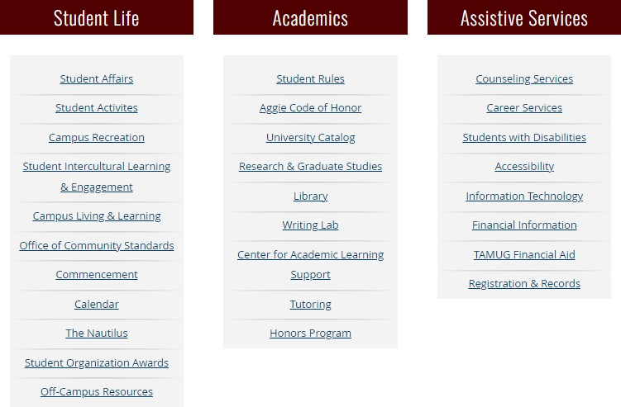**Snapshot of the Services offered:**